# [[2, Background: Rel-19 RAN1 proposal (by other companies)]]

Referring to Figurefigure 2, aspects of the present disclosure include the submission details for the invention titled "Dielectric Busbar Capacitors for IDT Coupling Adjustment." The date of submission is noted as 6/18/2024. The title succinctly describes the focus of the invention, emphasizing its relevance to coupling adjustments in Interdigital Transducers (IDTs). Furthermore, a table is to be completed on the following page, which will list all inventors along with their respective city of residence and country of citizenship. It is highlighted that a thoughtful list of all persons who contributed inventive concepts to the patentable ideas is essential, ensuring that both novel and useful ideas are recognized alongside their contributors’ details.

# [[3, Background: 2-CW and single-CW receiving]]

The prior solutions include the implementation of Reduced Complexity MIMO receivers utilizing two receive (Rx) port groups. For scenarios where the rank is greater than 4, a 2-Codeword (2-CW) Physical Downlink Shared Channel (PDSCH) is transmitted, targeting each Rx port group respectively, as depicted in Figure (a). In cases where the rank is less than or equal to 4, a single-Codeword (single-CW) PDSCH transmission may be employed. In these instances, the User Equipment (UE) may utilize Log-Likelihood Ratio (LLR) combining from the demodulation of the two Rx port groups, as illustrated in Figure (b). Alternatively, the UE may opt to use one of the two Rx port groups, either a fixed group or the one that exhibits superior Signal-to-Noise Ratio (SNR).

# [[4, Background: SRS for antenna switching (xTyR)]]

The prior solutions include the configuration of SRS resources for antenna switching (xTyR) within an SRS resource set, where the parameter "usage" is designated as "antennaSwitching." In this context, Q, defined as \( Q = \frac{y}{x} \), represents the number of SRS resources, each comprising x ports. It has been established that these Q SRS resources are transmitted using different symbols in a time-division multiplexing (TDM) manner. Each SRS resource is associated with distinct user equipment (UE) antenna ports, differentiating them from the other Q-1 resources. Historically, y has been constrained to integer multiples of x, exemplified by configurations such as 1T2R, 2T4R, 1T4R, 2T6R, and 4T8R, or scenarios where x equals y, such as 1T=1R, 2T=2R, and 4T=4R. Future developments may explore cases that deviate from this integer-multiple principle, including configurations like 4T6R and 3T8R.

# [[5, Motivation and issue]]

Aspects of the present disclosure include the exploration of SRS port grouping strategies tailored for foldable devices, specifically addressing the challenges posed by the physical design and RF circuitry limitations around hinge mechanisms. The two receive (Rx) antenna groups may correspond to the two Sounding Reference Signal (SRS) port groups, which are mounted on the two halves of the foldable device. The design considerations for SRS port grouping may be essential for optimizing performance in configurations such as 3T6R, 4T6R, and 3T8R. The complexity reduction in Multiple Input Multiple Output (MIMO) receivers may be achieved through effective port grouping, thereby enhancing signal processing capabilities. Additionally, the unique requirements of foldable phones may necessitate innovative approaches to antenna switching and Channel Quality Indicator (CQI) calculations, ensuring robust communication standards are maintained despite the constraints imposed by the device's form factor.

# [[6, Proposal for 3T6R]]

Referring to Figure 6, the dielectric capacitor can be implemented on one or both sides of the Interdigital Transducer (IDT). Implementation of the series capacitor on one side of the IDT is shown in the figure. In this aspect, the amount of series capacitance may be adjusted by changing all or any combination of the following parameters: busbar width, overlap length, dielectric thickness, and whether the capacitor is placed on one side or two sides of the IDT. The figure illustrates the busbar series gap, termed "Suhn Cap," which highlights the overlap necessary to create the series capacitor, as well as the components labeled M1 and M2, demonstrating the structural arrangement. The overlap is shown to be shorted with M1, indicating the connection necessary for effective capacitance.

# [[7, Proposal for 4T6R]]

Referring to Figure 7, aspects of the present disclosure include definitions relevant to series capacitors, specifically focusing on the busbar length, overlap width, dielectric thickness, and configurations involving one or two sides of the Interdigital Transducer (IDT). In this aspect, the figure illustrates the "BUSBAR SERIES GAP: 'SUHN CAP'," where the overlap is shown to create a series capacitor. The key parameters are highlighted: - **Dielectric Thickness (BLUE)** indicates the material thickness separating the conductive layers.- **Series cap on two sides** demonstrates a configuration where the series capacitor is formed on both sides of the IDT.- **Series cap on one side** depicts a configuration where the series capacitor exists on only one side of the IDT.- **Overlap Width** refers to the width of the overlapping conductive materials, which is critical for determining the capacitor's performance.- **Busbar Length** is measured to assess the effective length of the conductive path.The visual representation aids in understanding how these parameters interact and influence the overall design and functionality of capacitors in the context of foldable device technology.

# [[8, Proposal for 3T8R (Alt1)]]

Referring to Figure 8, the admittance plot illustrates the impact of implementing a series capacitor on coupling characteristics. In this aspect, coupling is defined as the frequency spacing between resonances and anti-resonances. The plot indicates two scenarios: one without a series capacitor and one with a series capacitor. The x-axis represents frequency in gigahertz (GHz), while the y-axis denotes magnitude in decibels (dB). The graph demonstrates that the addition of the series capacitor results in reduced coupling, as evidenced by the altered spacing between the resonance (fr) and anti-resonance (fa) points. Specifically, a reduction in this spacing correlates with a decrease in coupling, which facilitates the design of narrower band filters. The definition of coupling is mathematically expressed as \( Coupling = \frac{k^2_{eff}}{f^2_r - f^2_a} \), indicating that the admittance change reflects a smaller equivalent capacitance when the series capacitor is added.

# [[9, Proposal for 3T8R (Alt2)]]

Referring to Figure 9, the mBVD (multi-terminal Bonded Variable Device) model is illustrated, showcasing its components and the evaluation of equivalent capacitances at low and high frequencies.In this aspect, the evaluation of equivalent capacitances is conducted for the mBVD model, which consists of inductance (Lm), capacitance (Cm), and an additional capacitance (C0). The figure is divided into two sections representing low frequency and high frequency conditions.For low frequency, the impedance is represented as \( Z_L = j\omega L = 2\pi f L \). It is noted that as frequency approaches zero, the impedance \( Z_L \) approaches zero, leading to the equivalent capacitance \( C_{eq} = C_0 + C_m \) when the capacitor is shorted. At high frequency, the impedance is similarly represented, and as frequency approaches infinity, the impedance \( Z_L \) approaches infinity, resulting in the equivalent capacitance \( C_{eq} = C_0 \) when the capacitor is open. This evaluation is significant for understanding the behavior of the mBVD model across different frequency ranges, which is essential for optimizing antenna performance in foldable devices.

# Extracted Images

Image from Slide 2:

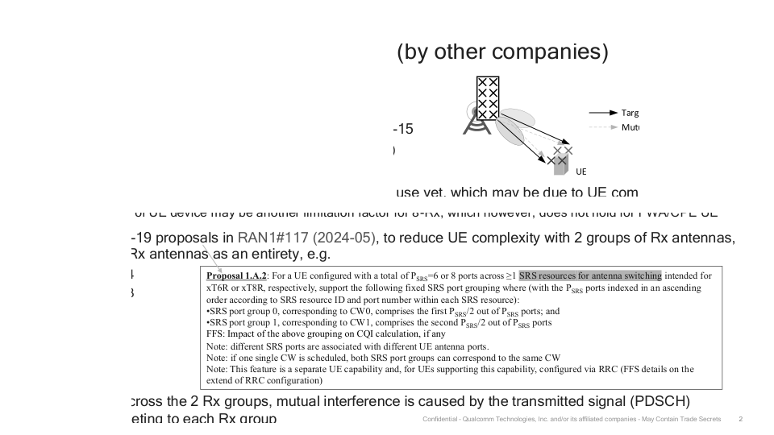

Image from Slide 3:

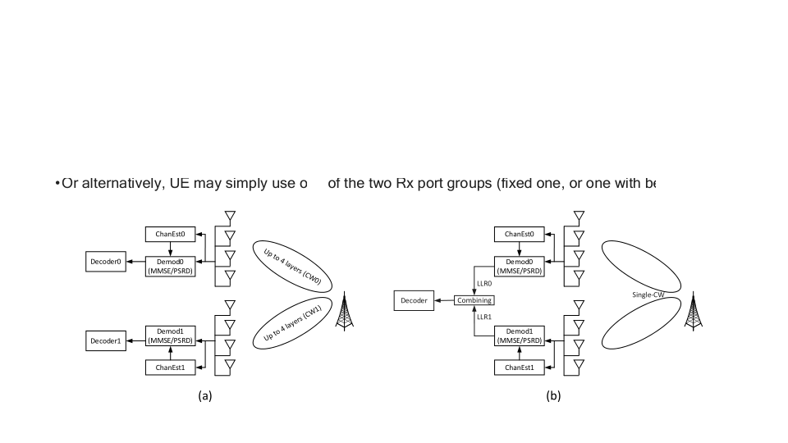

Image from Slide 6:

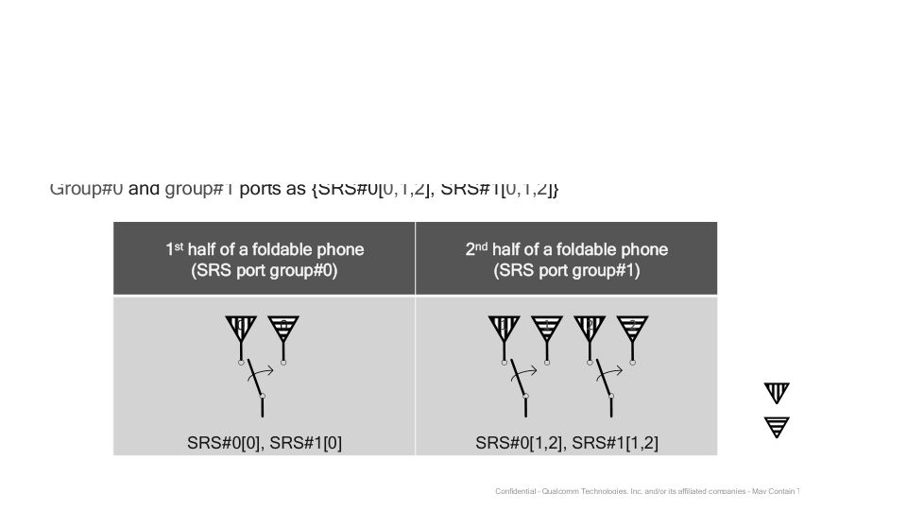

Image from Slide 7:

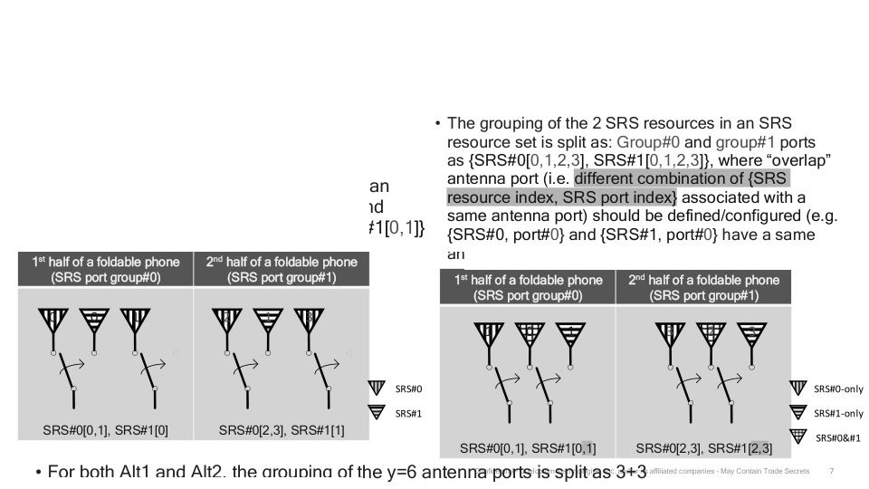

Image from Slide 8:

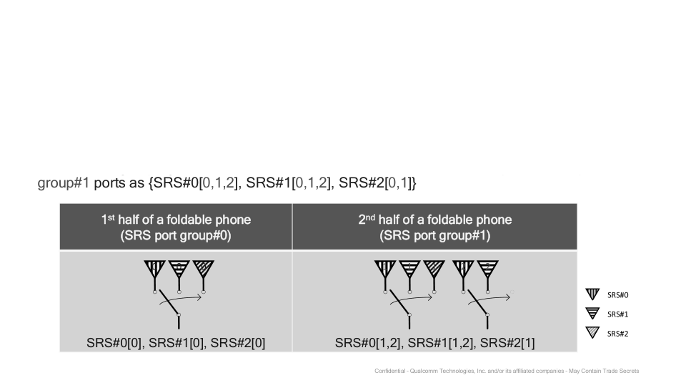

Image from Slide 9:

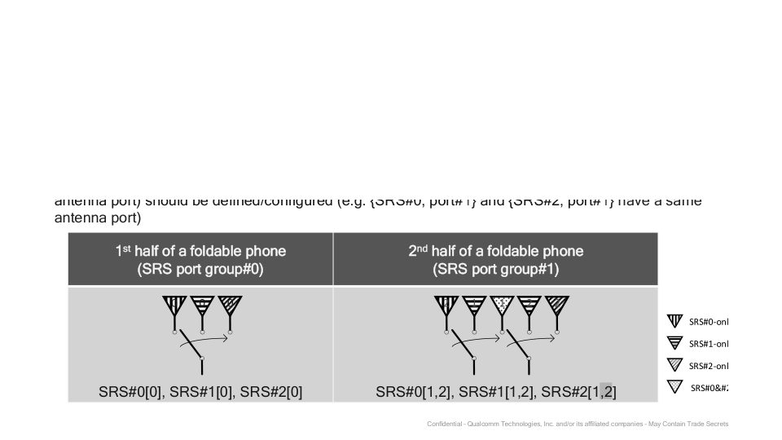

# Overall Theme

### Theme: **Innovative Antenna Design and Performance Optimization for Next-Gen Foldable Devices**  
  
#### Key Ideas and Keywords:  
- **SRS Port Grouping:** The strategic arrangement of Sounding Reference Signal (SRS) ports for enhanced antenna performance in foldable phones.  
- **MIMO (Multiple Input Multiple Output):** Techniques for reducing complexity in MIMO receivers through effective port grouping, enabling better signal processing.  
- **Antenna Switching (xTyR):** Configurations for multiple antenna ports to optimize signal reception and transmission across foldable device designs.  
- **CQI Calculation:** Considerations on how SRS port grouping impacts Channel Quality Indicator calculations, essential for maintaining optimal communication standards.  
- **Foldable Phone Design:** Addressing unique challenges in RF circuitry due to the physical design of foldable devices, particularly around hinge mechanisms.  
- **Proposal Variants (3T6R, 4T6R, 3T8R):** Detailed proposals illustrating different configurations of transmit (Tx) and receive (Rx) antenna ports to maximize performance.  
- **Dielectric Capacitor Innovations:** Enhancements in coupling adjustment for Interdigital Transducers (IDTs) that support the overall performance of foldable devices.  
- **Coupling Characteristics:** Understanding and manipulation of coupling parameters to achieve improved filter designs and signal integrity.  
- **Admittance Plot Analysis:** Visual representations that compare performance metrics with and without series capacitors, emphasizing design flexibility.  
  
#### Cohesive Summary:  
The presentation encapsulates a forward-thinking approach to optimizing antenna design and performance in foldable smartphones. By leveraging innovative SRS port grouping strategies and advanced MIMO techniques, the proposals aim to enhance signal quality and reduce complexity in receiver designs. The integration of dielectric capacitors for coupling adjustment further illustrates a commitment to pushing the boundaries of current technology, addressing the unique challenges posed by foldable form factors. Through detailed configurations and visual analyses, the content emphasizes the importance of adaptability and precision in next-generation device engineering, ensuring robust communication capabilities in an evolving market.